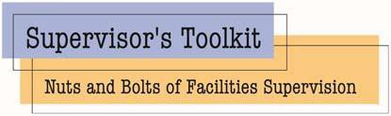

UNIVERSITY OF OREGON

August 5-7, 2024

Registration Form
Please submit the registration form to Debbi Davis at debdavis@uoregon.edu for processing.

Personal Information

First Name Last Name Title Institution Name Phone Email Address City State Zip

Registration Deadline: July 12th, 2024 Reserve Early – Class Size is Limited.

Payment Information:
Registration fee is $600 for APPA members and $795 for non-members. This fee includes all course materials, breakfast, lunch, and afternoon snack daily.

Once the registration form is received, we will send an invoice for the registration fee. If someone other than the attendee should receive the invoice, please list their email below.
Send invoice to: ___________________________________________________________________

Accommodations and Travel:

Nearest airport is the Eugene Airport, also known as Mahlon Sweet Field (EUG) located approximately 10 miles from campus and hotels. Uber and Taxis are available at the airport.

Hotels w/in walking distance:
- Best Western New Oregon
- Hayward Inn
- Holiday Inn Express & Suites Eugene Downtown University

If driving, parking permits are required on campus - https://uoregon.aimsparking.com/permits/?cmd=new_non_auth

Contact Debbi Davis at 541-346-8421 or debdavis@uoregon.edu with any questions.

